# Spring Boot Project Documentation

Created by: **Anand R Diwatai**

### Date : 29/12/2024

## Introduction:

This document outlines the steps to set up and run a Spring Boot project that performs CRUD operations on Categories and Products, including testing with Postman. The project also demonstrates server-side pagination and linking of products with categories.

## Steps to Run the Code:

1. Step 1: Create a Spring Boot project using Spring Initializr or your preferred IDE.

* **Dependencies**:
  + Spring Web
  + Spring Data JPA
  + MySQL Driver
  + Spring Boot DevTools
  + Hibernate

1. Step 2: Set up application.properties to connect with MySQL or H2 for testing.
2. Step 3:Create Category and Product Entities - Define Category and Product entities.
3. Step 4: Create Repository Interfaces - Set up repository interfaces for Category and Product.
4. Step 5:Create Controller for CRUD Operations - Create a controller for performing Create, Read, Update, Delete operations for both categories and products.
5. Step 6: Implement Server-Side Pagination - Implement pagination for fetching categories and products.
6. Step 7:Fetch Product with Category Details - Ensure products are linked to their categories and can be fetched together
7. Step 8: Testing with Postman.

## Postman Testing:

Use Postman to test the following endpoints for Categories and Products.

Categories Endpoints:

1. **POST - create a new category**

* URL: http://localhost:8080/api/categories
* Method: POST

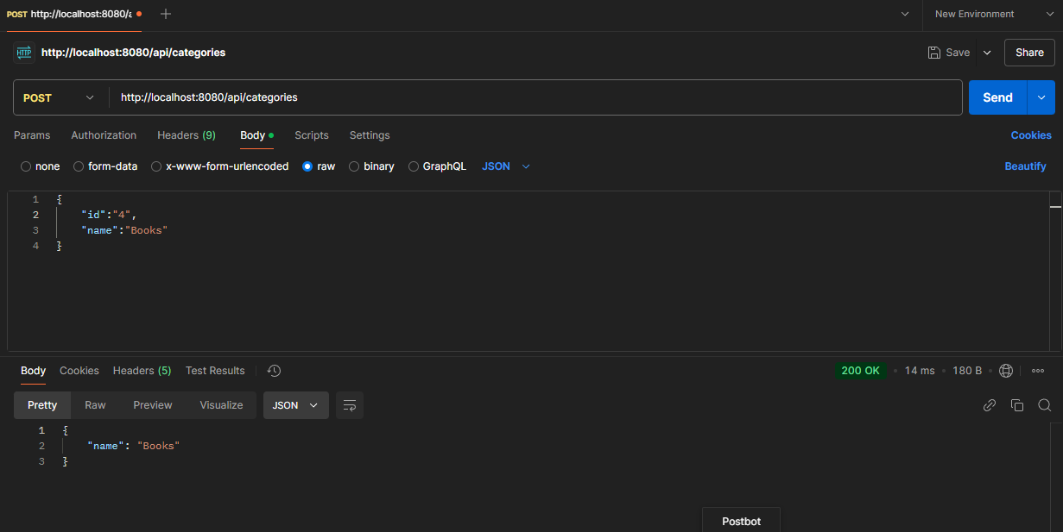

1. **GET all the categories**

* URL: http://localhost:8080/api/categories?page=0
* Method: GET
* 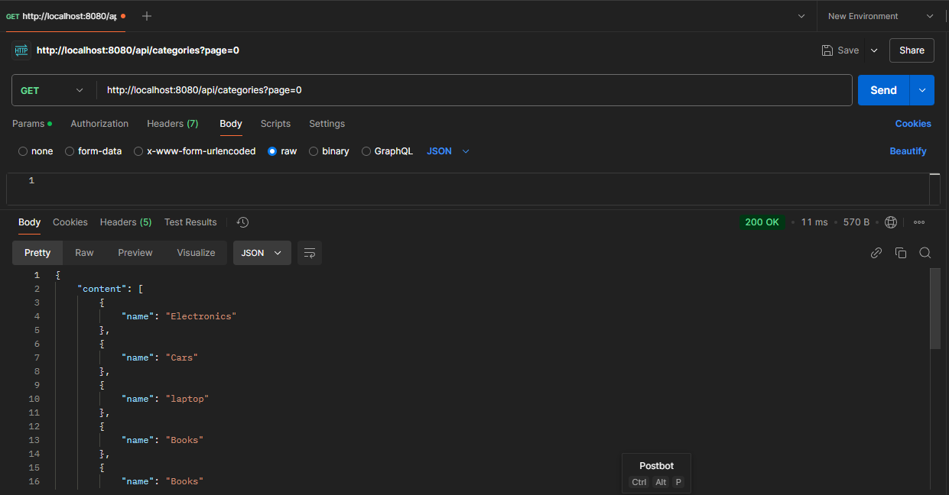

1. **GET category by Id**

* URL: http://localhost:8080/api/categories/1
* Method: Get  
    
  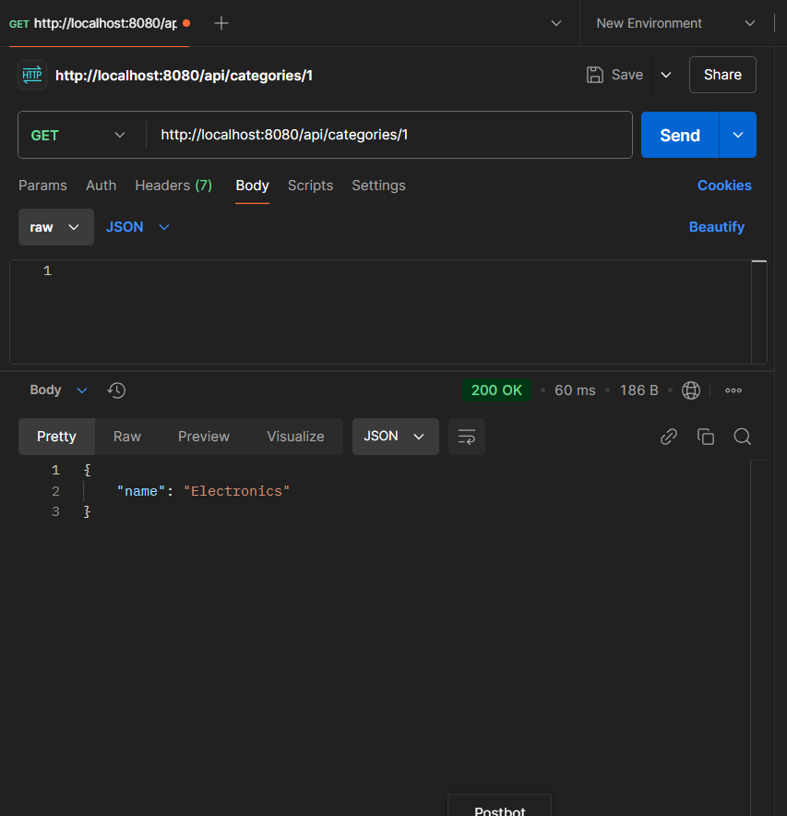

**4 . PUT - updatecategory by id**

* URL: <http://localhost:8080/api/categories/1>
* Method : Put
* 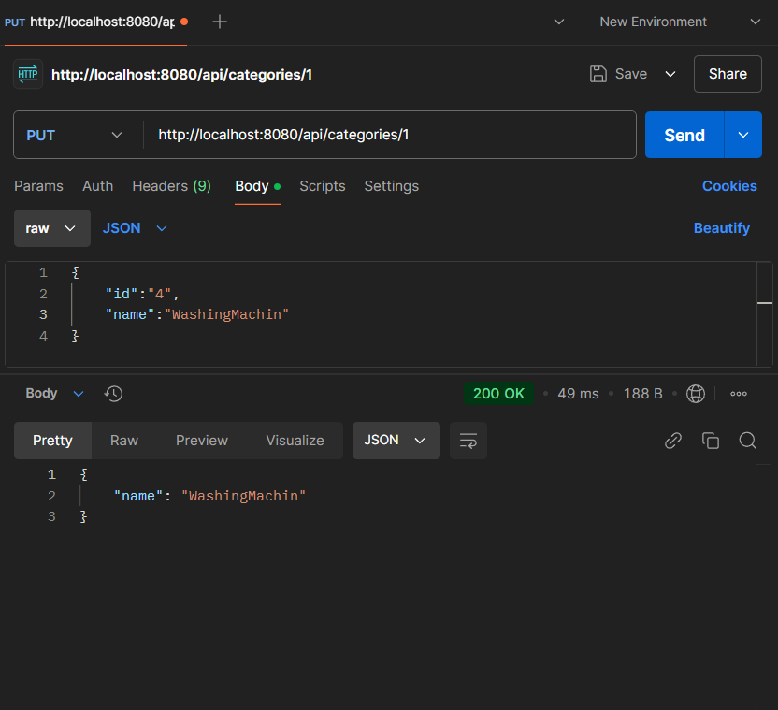

**5 . Delete category By ID**

* URL: http://localhost:8080/api/categories/1
* Method: DELETE

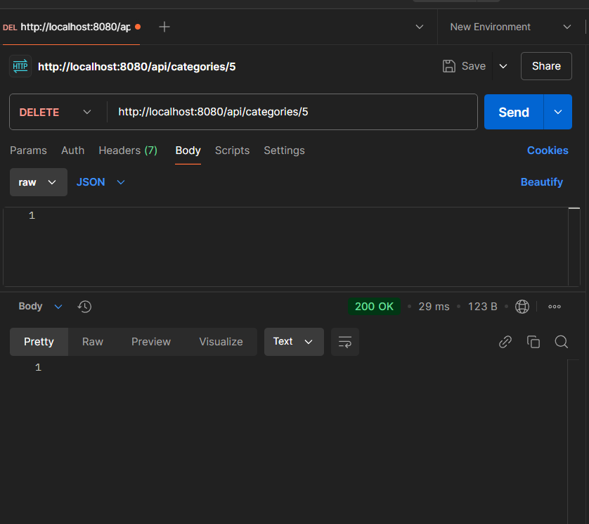

**Products Endpoints:**

**1.POST - create a new product**

* URL: http://localhost:8080/api/products
* Method: POST

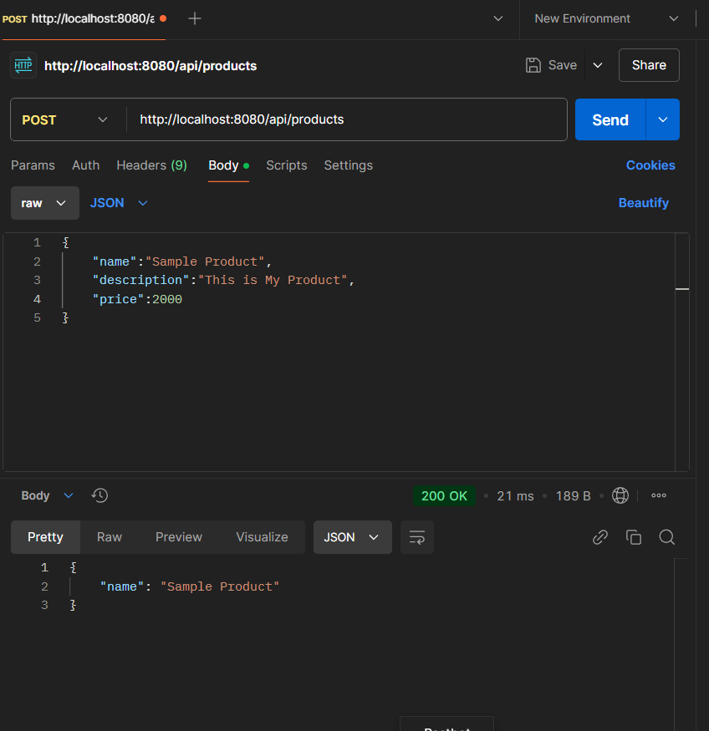

1. **GET all the products**

* URL:[http://localhost:8080/api/products?page=](http://localhost:8080/api/products?page=2" \t "https://mail.google.com/mail/u/0/" \l "sent/_blank)0
* Method: GET

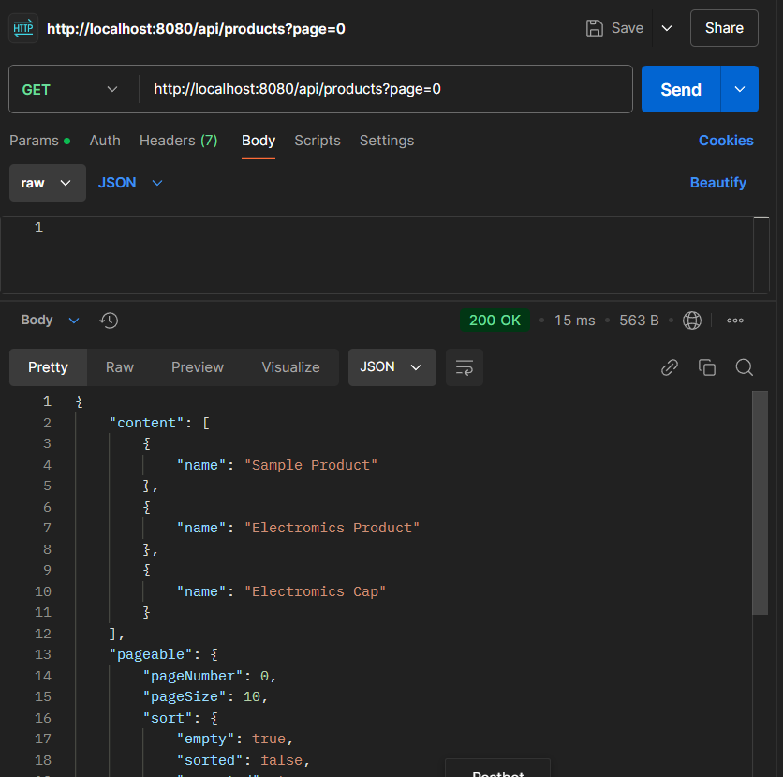

1. **GET product by Id**

* URL: http://localhost:8080/api/products/1
* Method: Get

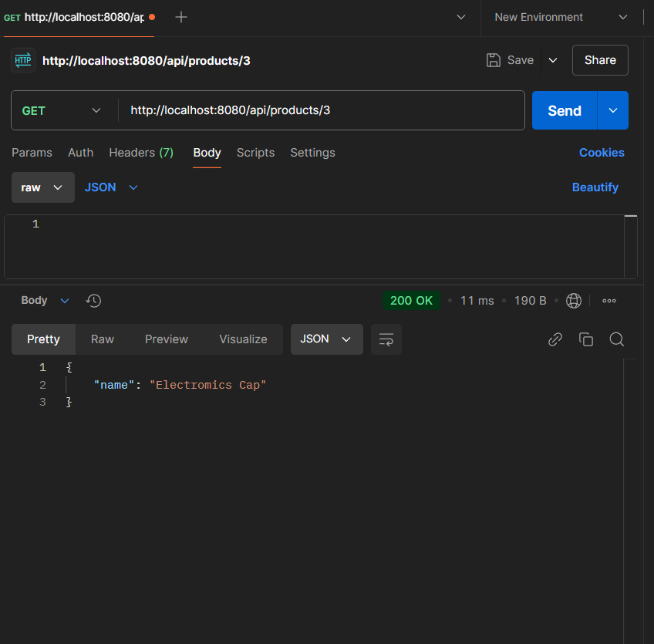

1. **PUT - update product by id**

Url : [http://localhost:8080/api/products/](http://localhost:8080/api/products/{di}" \t "https://mail.google.com/mail/u/0/" \l "sent/_blank)3

Method : PUT

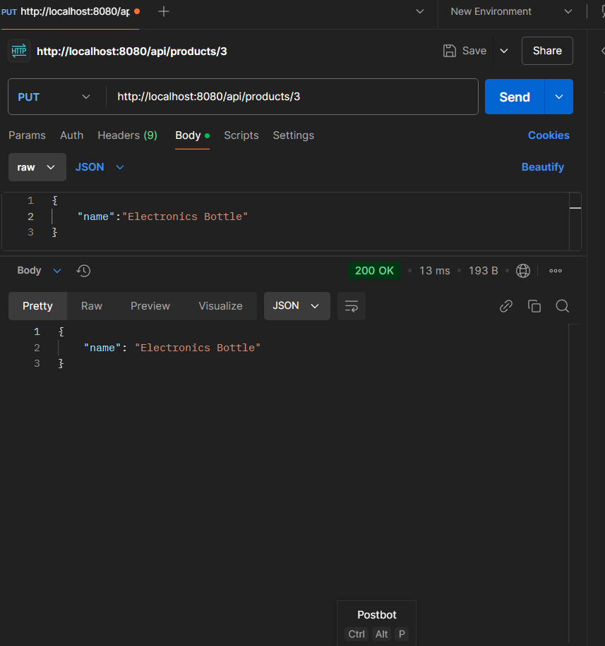

1. **DELETE - Delete product by id**  
   Url : [http://localhost:8080/api/products/](http://localhost:8080/api/products/{di}" \t "https://mail.google.com/mail/u/0/" \l "sent/_blank)3

Method : Delete

